TOPIC 3 - DIVIDE & CONQUER
Q1. Merge Sort
Aim:
To sort an array using divide-and-conquer (Merge Sort) technique. Algorithm:
- Divide array into halves.
- Recursively sort each half.
- Merge two sorted halves.
- Compare elements while merging.
- Return merged sorted array.
Code:
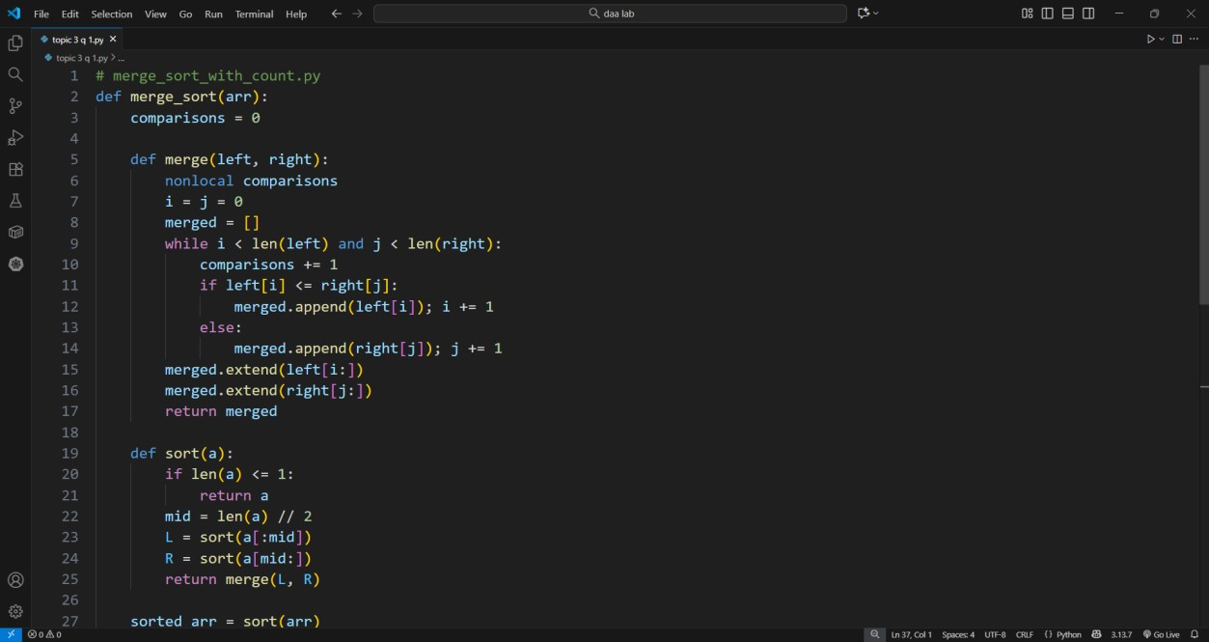

Input: [12, 4, 78, 23, 45, 67, 89, 1] Output:
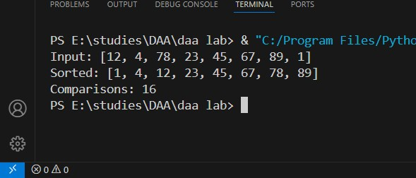

Result: Array sorted successfully via merge sort.

Q2. Quick Sort
Aim:
To sort numbers using quick sort by selecting a pivot and partitioning recursively. Algorithm:
- Choose pivot (first or middle element).
- Partition array into < pivot and > pivot groups.
- Recursively sort subarrays.
- Combine results.
- Return sorted list.
Code:
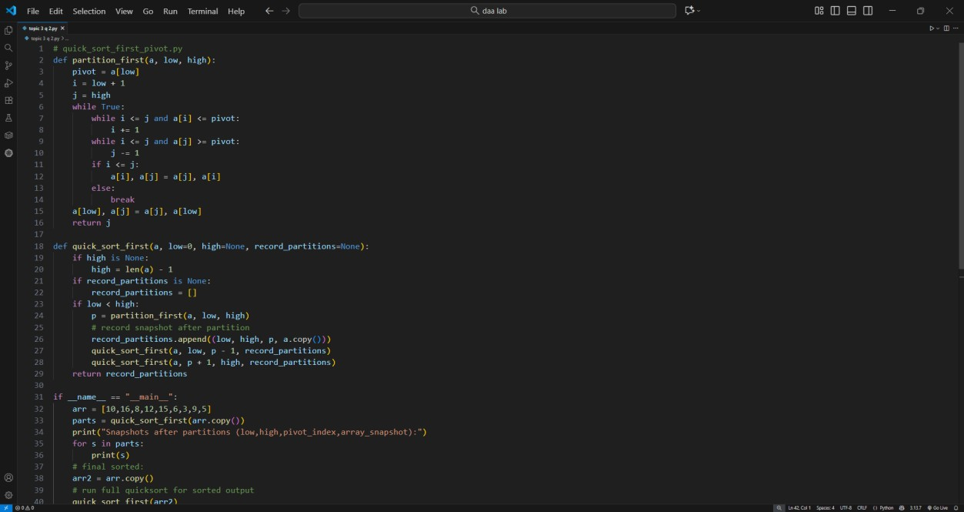

Input: [10,16,8,12,15,6,3,9,5] Output:
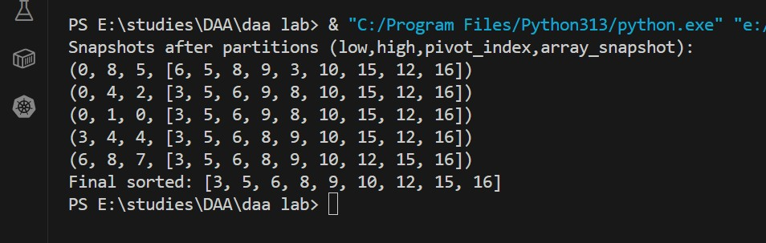
Result: Array sorted with quick sort logic.

Q3. Binary Search
Aim:
To find an element in a sorted array efficiently using binary search. Algorithm:
- Set low=0, high=n−1.
- Find mid index.
- Compare mid value with key.
- Adjust range accordingly.
- Continue until found or range ends.
Code:
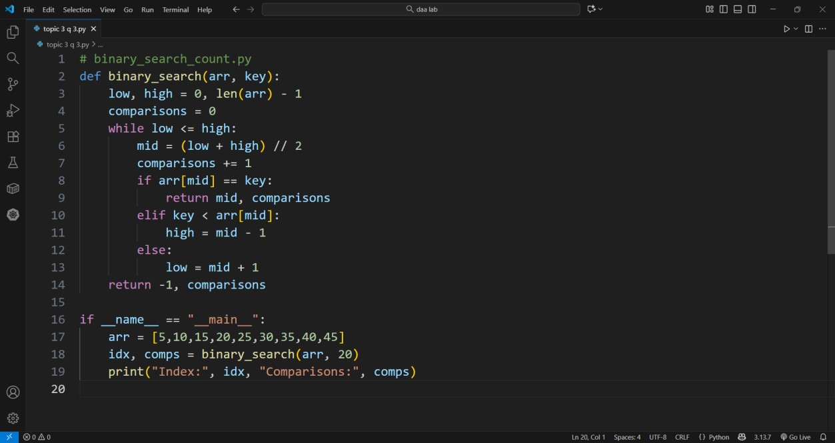
Input: [5,10,15,20,25,30,35,40,45], key=20
Output:
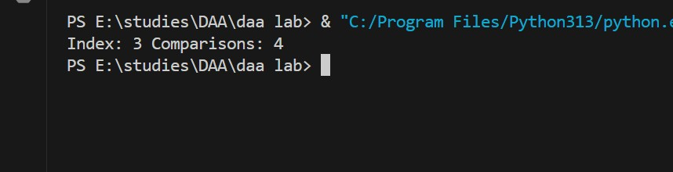

Result: Binary search found the element in O(log n).

Q4. Median of Medians
Aim:
To find the k-th smallest element in an unsorted array using the median-of-medians method. Algorithm:
- Divide array into groups of 5.
- Sort each group and find median.
- Find median of medians recursively.
- Partition array around pivot.
- Recurse in desired partition.
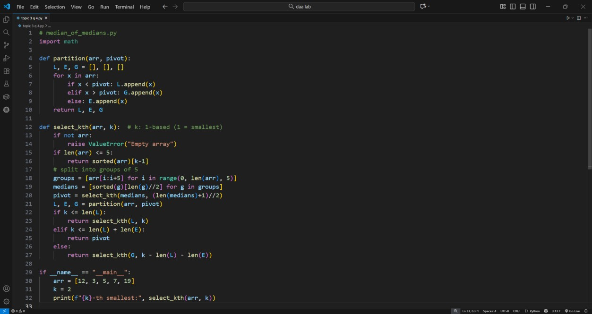

Input: [12,3,5,7,19], k=2

Output:
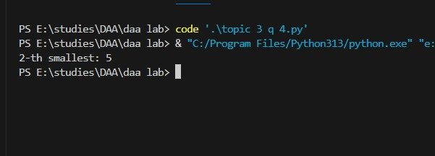

Result: 2nd smallest element correctly found.

Q5. Strassen’s Matrix Multiplication
Aim:
To multiply two matrices efficiently using Strassen’s algorithm. Algorithm:
- Split matrices into four sub-matrices.
- Compute 7 products recursively.
- Combine them using Strassen’s formulas.
- Form resultant matrix.
- Display output.
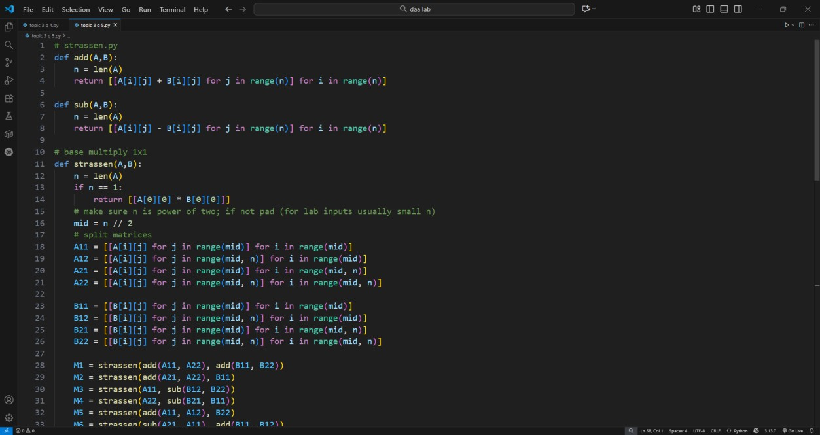

Input:
A = [[1,7],[3,5]], B = [[6,8],[4,2]]
Output:
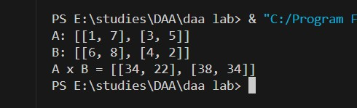

Result: Matrix multiplication done efficiently.

